Title: RTL Design of Finite State Machines (FSM) and Control Units
Intern Name: Lagisetty Vidya Charan
College: Mohan Babu University
Department: Electronics and Communication Engineering
Internship: VLSI Design Internship
Tool Used: Xilinx Vivado
HDL: Verilog HDL
Simulation: Vivado Behavioral Simulation
- Introduction:

A Finite State Machine (FSM) is a sequential digital system that operates through a finite number of predefined states. The FSM changes from one state to another depending on the current state, input conditions and clock signal.
FSMs are widely used in digital systems for implementing control logic. They are commonly used in processors, communication protocols, embedded systems and ASIC/FPGA controllers. The Task 4 document specifically introduces FSMs as an important part of control-driven digital design.
An FSM generally consists of:
- States
- Inputs
- Outputs
- State transitions
There are two major types of FSM:
Moore FSM
In a moore machine, the output depends only on the current state.
Output=f(State)
Mealy FSM
In a mealy machine, the output depends on both the current state and input
Output=f(State, Input)
These definitions and concepts are part of the FSM fundamentals specified in the task.
- Objectives:
The objectives of this task are:
- To understand the fundamentals of Finite State Machines.
- To understand the difference between Moore and Mealy FSMs.
- To design FSMs using Verilog HDL.
- To implement a traffic light controller using an FSM.
- To design a binary sequence detector for the pattern 1011.
- To develop testbenches for the RTL designs.
- To perform behavioral simulation using Xilinx Vivado.
- To analyze state transitions and output behavior using simulation waveforms.
- Software And Tools Used:
Xilinx Vivado
Xilinx Vivado was used for:
- Creating the RTL project
- Writing Verilog modules
- Creating simulation testbenches
- Running behavioral simulations
- Viewing simulation waveforms
- Verifying state transitions and outputs
- MOORE FSM
  - Problem Statement
Design a simple FSM that continuously cycles through three states:
S0 → S1 → S2 → S0
The state encoding used is:
State | Binary
S0 | 00
S1 | 01
S2 | 10
This is the Moore FSM example
  - Working Principle
The FSM uses a clock and reset signal.
When reset is asserted, the FSM enters state S0.
After reset is released, the FSM changes state on every positive edge of the clock.
The transition sequence is:
S0 → S1
S1 → S2
S2 → S0
The state is stored in a 2-bit register.
  - Verilog Implementation
module moore_fsm(
input clk,
input reset,
output reg [1:0] state
);

parameter S0 = 2'b00,
S1 = 2'b01,
S2 = 2'b10;

always @(posedge clk or posedge reset) begin
if (reset)
state <= S0;
else begin
case (state)
S0: state <= S1;
S1: state <= S2;
S2: state <= S0;
default: state <= S0;
endcase
end
end

endmodule
  - Testbench
The testbench generates a clock and applies reset to the FSM.
module tb_moore_fsm;

reg clk;
reg reset;
wire [1:0] state;

moore_fsm uut (
.clk(clk),
.reset(reset),
.state(state)
);

initial clk = 0;
always #5 clk = ~clk;

initial begin
reset = 1;
#10;
reset = 0;
#50;
$finish;
end

endmodule

  - Simulation Result
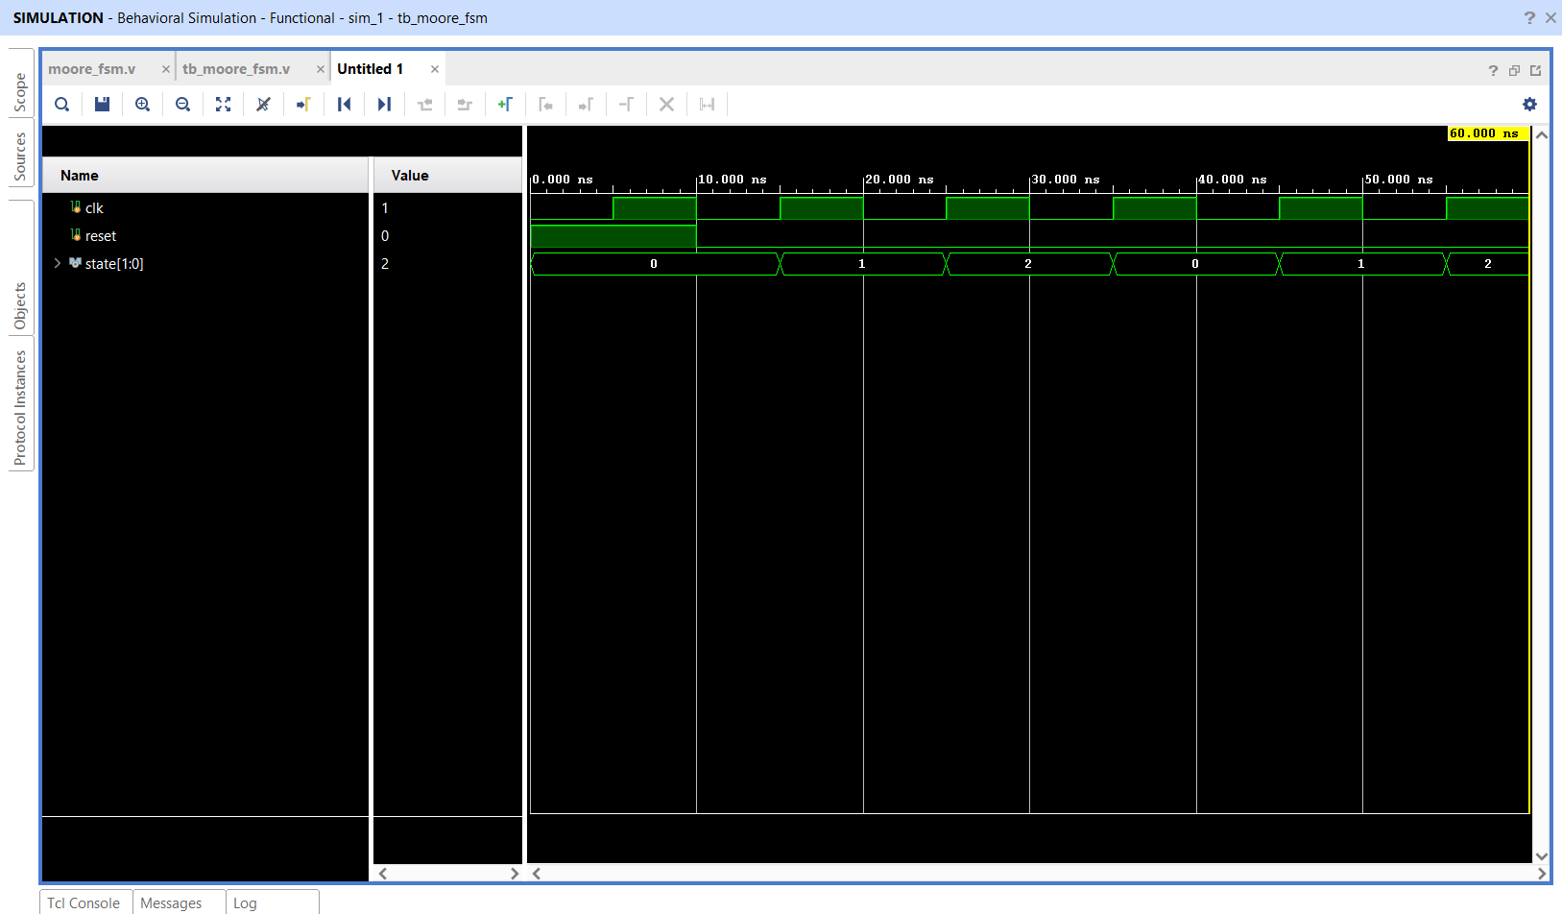
Observation:
The simulation waveform shows that the FSM starts from S0 after reset and continuously cycles through:
00 → 01 → 10 → 00
Therefore, the required Moore FSM state transitions were successfully verified.
- Mealy FSM
  - Problem Statement
The Mealy FSM is designed such that the output becomes HIGH when:
Current State = S1
AND
Input = 1
  - State Transition Table
Current state | Input | Next state | Output
S0 | 0 | S0 | 0
S0 | 1 | S1 | 0
S1 | 0 | S0 | 0
S1 | 1 | S0 | 1
The important condition is:
S1 + Input 1 → Output 1
  - Working Principle
Initially, the FSM is in S0.
When input becomes 1, the FSM transitions from S0 to S1.
If the next input is also 1, the FSM produces:
out=1
because the current state is S1 and the input is 1.
This demonstrates that the output depends on both state and input.

  - Verilog Implementation
`timescale 1ns / 1ps

module mealy_fsm(
input clk,
input reset,
input in,
output reg out
);

reg state;

parameter S0 = 1'b0,
S1 = 1'b1;

always @(posedge clk or posedge reset) begin
if (reset) begin
state <= S0;
out <= 1'b0;
end
else begin
case (state)

S0: begin
if (in) begin
state <= S1;
out <= 1'b0;
end
else begin
state <= S0;
out <= 1'b0;
end
end

S1: begin
if (in) begin
out <= 1'b1;
state <= S0;
end
else begin
out <= 1'b0;
state <= S0;
end
end

default: begin
state <= S0;
out <= 1'b0;
end

endcase
end
end

endmodule
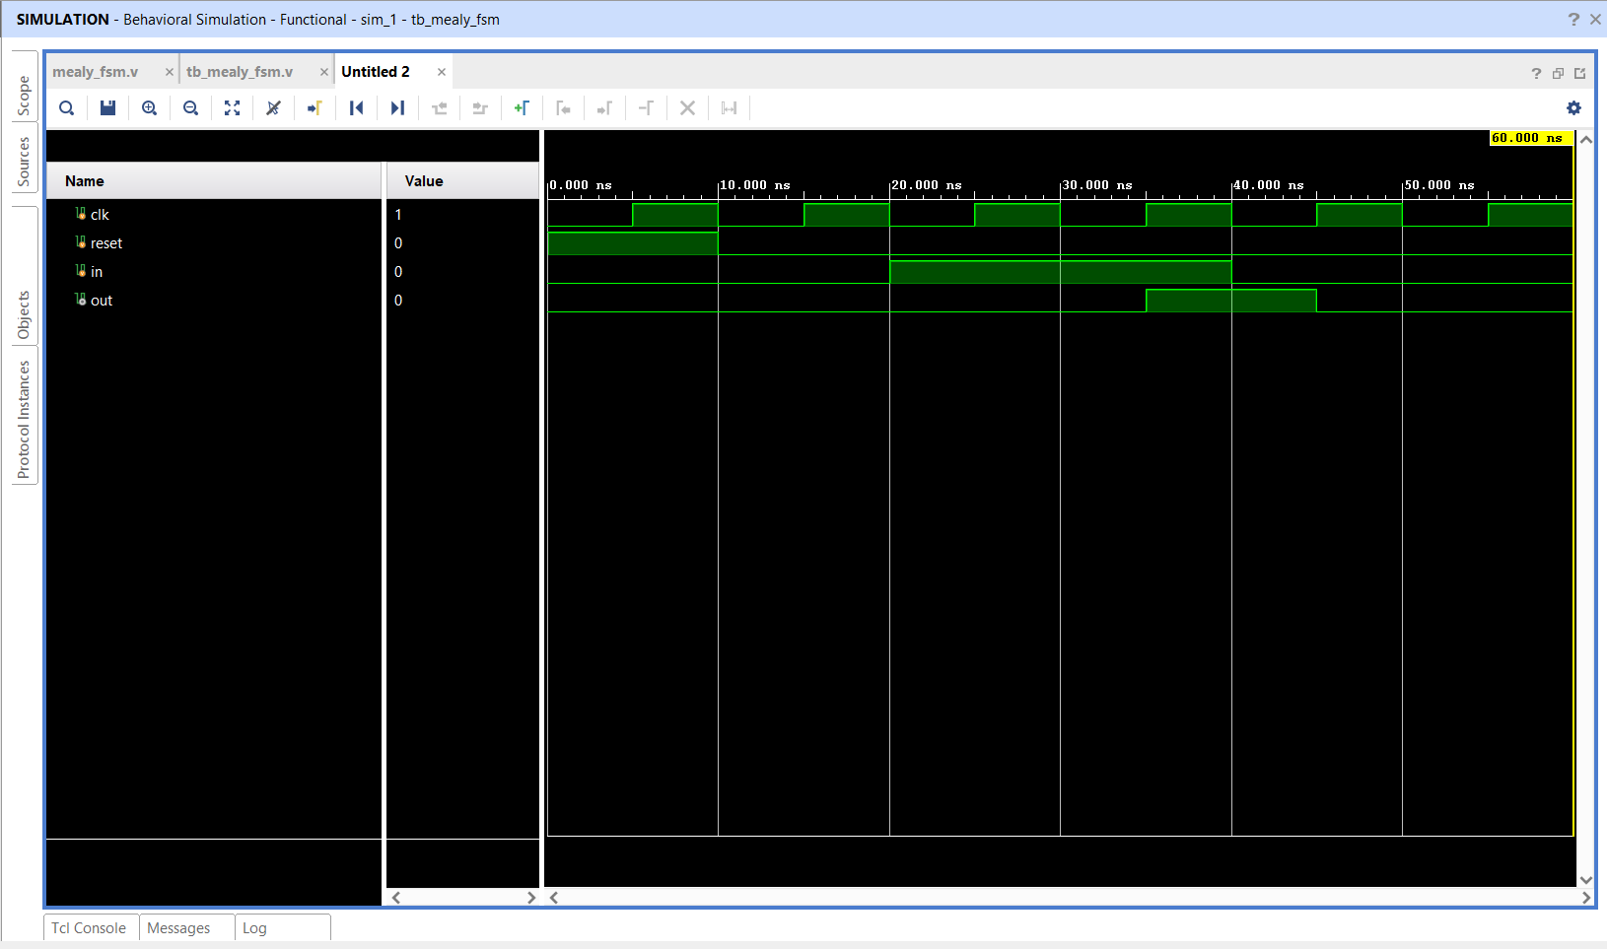
  - Simulation Result
Observation: The simulation verifies that the output becomes HIGH when the FSM is in S1 and the input is 1.
This demonstrates the fundamental difference between Moore and Mealy machines: the Mealy output is influenced by the input as well as the current state.
- Traffic Light Controller
  - Problem Statement
A traffic light controller is implemented using an FSM.
The task defines:
State | Light
S0 | RED
S1 | YELLOW
S2 | GREEN
The light encodings are:
RED = 100
YELLOW = 010
GREEN = 001
These values are given in the task’s starter design.

  - Working Principle
The controller uses a 2-bit state register.
After reset:
State=S0
Light=RED
The controller then progresses through the defined states on every positive clock edge.
The implemented output sequence observed in simulation is:
RED → GREEN → YELLOW → RED
The corresponding binary values are:
100 → 001 → 010 → 100
  - Verilog Implementation
`timescale 1ns / 1ps

module traffic_light(
input clk,
input reset,
output reg [2:0] light
);

parameter RED = 3'b100,
YELLOW = 3'b010,
GREEN = 3'b001;

reg [1:0] state;

parameter S0 = 2'b00,
S1 = 2'b01,
S2 = 2'b10;

always @(posedge clk or posedge reset) begin

if (reset) begin
state <= S0;
light <= RED;
end

else begin
case (state)

S0: begin
state <= S1;
light <= GREEN;
end

S1: begin
state <= S2;
light <= YELLOW;
end

S2: begin
state <= S0;
light <= RED;
end

default: begin
state <= S0;
light <= RED;
end

endcase
end

end

endmodule
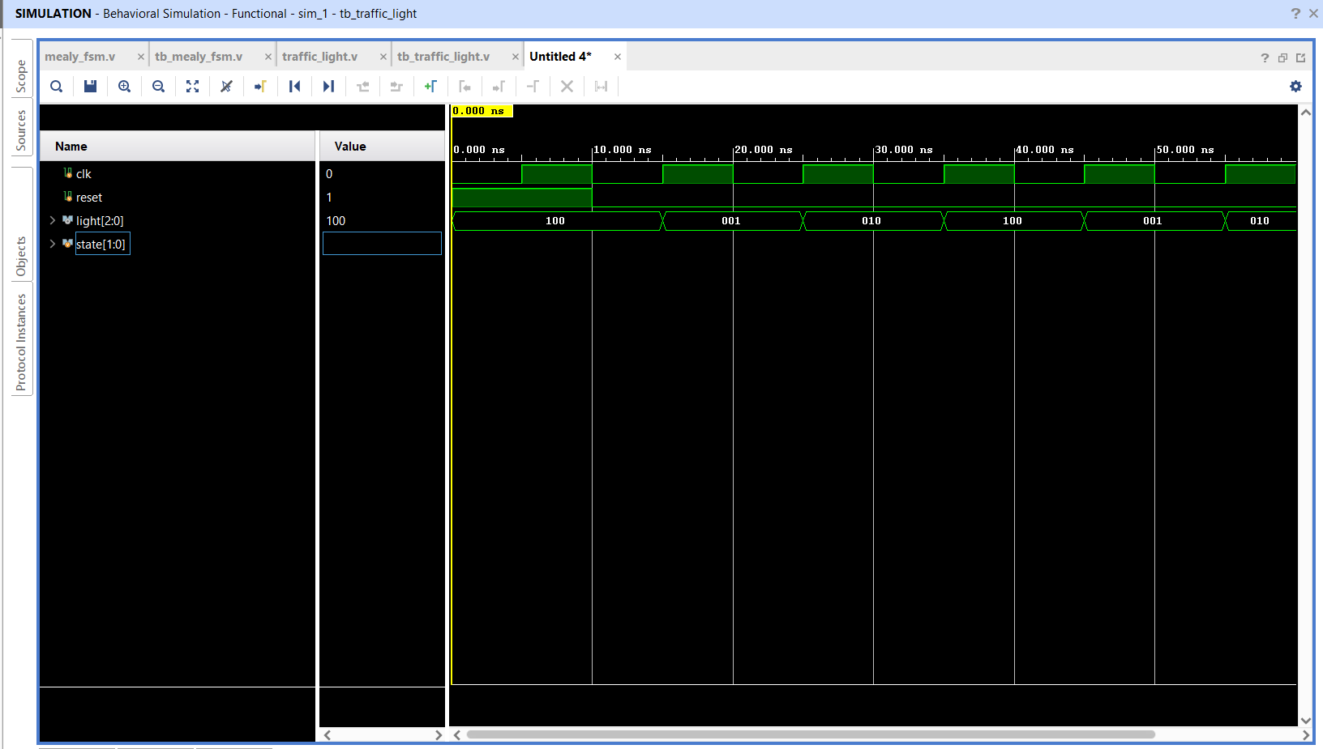
  - Simulation Result
Observation: The waveform confirms that the controller changes its light output according to the FSM state and that the sequence repeats continuously after reset.

- 1011 Sequence Detector
  - Problem Statement
The objective is to detect the binary sequence:
1011
from a serial input stream.
  - State Definition
Four states are used.
State | Meaning | Encoding
S0 | No bits matched | 000
S1 | 1 detected | 001
S2 | 10 detected | 010
S3 | 101 detected | 011
  - Working Principle
The FSM remembers how many bits of the required pattern have already been received.
Step 1
Input: 1
The FSM moves: S0 → S1
Now one bit of the pattern has been matched.
Step 2
Input: 0
The FSM moves: S1 → S2
The matched pattern is now: 10
Step 3
Input: 1
The FSM moves: S2 → S3
The matched pattern is: 101
Step 4
Input: 1
The complete pattern becomes: 1011
Therefore: detected=1
  - Verilog Implementation
`timescale 1ns / 1ps

module sequence_detector(
input clk,
input reset,
input in,
output reg detected
);

reg [2:0] state;

parameter S0 = 3'b000,
S1 = 3'b001,
S2 = 3'b010,
S3 = 3'b011;

always @(posedge clk or posedge reset) begin

if (reset) begin
state <= S0;
detected <= 1'b0;
end

else begin

case (state)

// No matching bits
S0: begin
detected <= 1'b0;

if (in)
state <= S1;
else
state <= S0;
end

// Detected "1"
S1: begin
detected <= 1'b0;

if (in)
state <= S1;
else
state <= S2;
end

// Detected "10"
S2: begin
detected <= 1'b0;

if (in)
state <= S3;
else
state <= S0;
end

// Detected "101"
S3: begin
if (in) begin
detected <= 1'b1;
state <= S1;
end
else begin
detected <= 1'b0;
state <= S2;
end
end

default: begin
state <= S0;
detected <= 1'b0;
end

endcase

end

end

endmodule
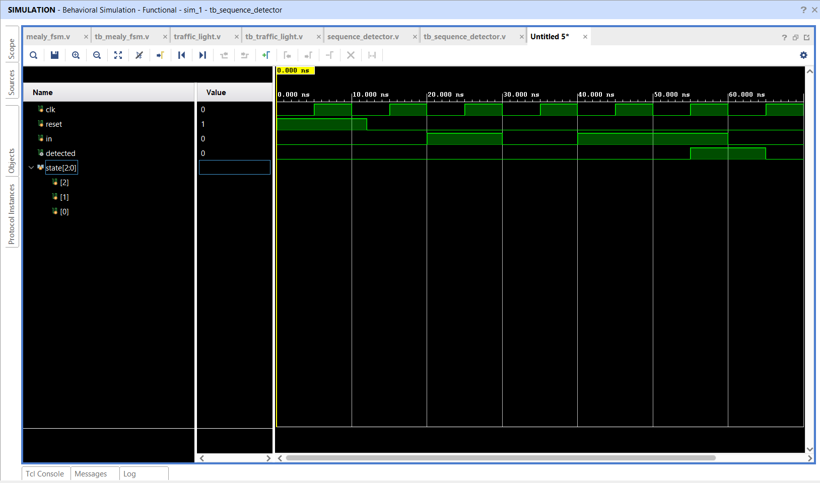
  - Simulation Result
The important waveform relationship is:
Input: 1 → 0 → 1 → 1
State: S0 → S1 → S2 → S3
Detection: 0 → 0 → 0 → 1
Observation: The simulation successfully detects the 1011 sequence. The detected signal becomes HIGH after the final 1 is received.
The implementation also returns to S1 after detection, allowing another sequence beginning with 1 to be recognized.
- Comparison of Moore and Mealy FSM
Feature | Moore FSM | Mealy FSM
Output depends on | State | State + Input
Output timing | State dependent | Can respond to input
Design used | 3-state counter like FSM | Input dependent output FSM
Main concept demonstrated | State transition | State + input control
Output behavior | Determined by current state | Determined by current state and input
- Simulation And Verification
All four designs were verified using Vivado Behavioral Simulation.
The verification process consisted of:
1. Creating the RTL module.
2. Creating a corresponding Verilog testbench.
3. Generating a clock signal.
4. Applying reset.
5. Applying required input patterns where applicable.
6. Running behavioral simulation.
7. Observing state transitions.
8. Observing output signals.
9. Comparing the waveform against the expected behavior.
The task specifically requires waveform analysis to verify state transitions, output timing and reset behavior.
- Results
The following results were obtained:
Design | Result
Moore FSM | Successfully cycled through S0 → S1 → S2
Mealy FSM | Output HIGH for S1 with input=1
Traffic Light Controller | Successfully generated RED → GREEN → YELLOW sequence
1011 Sequence Detector | Successfully detected 1011
Therefore, all four RTL designs were successfully simulated and verified.
- Learning Outcomes
Through this task, the following concepts were understood:
- Finite State Machine architecture
- Moore FSM
- Mealy FSM
- State encoding
- State transition logic
- Sequential Verilog design
- always @(posedge clk or posedge reset)
- case-based FSM implementation
- Testbench development
- Behavioral simulation
- Waveform analysis
- Traffic-light control using FSM
- Serial pattern detection
- Overlapping sequence detection
- Conclusion
The Task 4 objective of implementing FSM-based RTL designs was successfully achieved using Verilog HDL and Xilinx Vivado.
Four different FSM applications were implemented: a Moore FSM, a Mealy FSM, a traffic light controller and a 1011 sequence detector. Each design was tested using a dedicated Verilog testbench and verified through behavioral simulation waveforms.
The simulations demonstrated correct state transitions, reset behavior and output generation. The task also provided practical understanding of how FSMs are used to implement control logic in digital systems.

